Epsom & Ewell F.C.
24
v
Cove F.C.
Tuesday, 15th March 2016 – 7.45 p.m.
Good evening! We welcome the players, supporters and officials of Cove Football club for a League match, together with today’s match officials and our own regular supporters.

We were of course due to meet originally on 8th December but our opponents were unable to fulfil the fixture, and it is pleasing to report that the division’s second longest serving club (after Raynes Park Vale) are at the very least back on their feet, even if survival this year, their twentieth in the top division, looks remote. It appears highly likely that all three clubs who finish below the line could well be relegated this season.

We met for our first league meeting of the season over at Oak Farm in early October and got off to a flying start with two goals in the opening five minutes, eventually winning 7-0. However, our visitors have improved after their break and have recently claimed a draw against Spelthorne and a win over Chessington & Hook United. They have still to pick up a point on their travels though and whilst we sympathise with their plight, must ensure that this remains the case following our match if we are to keep up the pressure on the top teams.

Three days ago we hosted Knaphill here and we led at half time through James Taylor but lost 2-1 after the pressure of playing with ten men finally wore us down. Our keeper Adrian Jones had been sent off in the first half and with Michael Eacott away, Dan Dean had the “honour” of having to go between the posts for the remainder of the match. I’m sure he would have laughed if someone had told him before the game that two Knaphill players would fail to score from the spot against him! Funnily enough, at half time, one of our (unnamed) players asked for me not to mention that he had saved a penalty as it had actually been missed. It’s true that the first one was, but the second was all down to Deano!! It’s just a pity that the heroics didn’t earn us any points in the end.

On Saturday, we are scheduled to travel to Chessington & Hook and then to Farnham on Tuesday. Both of these pitches have had real trouble this season and it is quite possible that either or even both fixtures may end up being postponed. Hopefully you will all be in attendance for our newly rearranged league match against Westfield on the Good Friday. Please note the unusual start time of 1pm for this match.

Our club suggested this move from the Saturday and believe that the date is a criminally underused one in the football calendar. It means we may attract a few “floating voters” and will also give both us and Westfield an extra day to recover before our Monday morning fixtures. Ours is at Raynes Park Vale. If this works out we may do it again, so please let everyone know.

Enjoy the game!

Rich

You can now follow us on Facebook www.facebook.com/epsomandewellfc or Twitter @EEFCOfficial
and we are now on Instagram too at www.instagram.com/epsomandewellfc

Cover Photos by Gemma Jarman

- Bentley Graham scores his first goal for the club in our recent 5-3 win at Chertsey Town
- Kyle Hough strikes our third goal in that match

Cherry Red Records Combined Counties League
Premier Division Table 2015/16
inc Saturday 12th March | P | W | D | L | F | A | Pts | GD | H | A
Hartley Wintney | 29 | 24 | 2 | 3 | 86 | 28 | 74 | +58 | 0-1 | 3-3
Ashford Town (Mx) | 32 | 23 | 2 | 7 | 86 | 43 | 71 | +42 | 30/4 | 3-2
Epsom & Ewell | 31 | 18 | 8 | 5 | 71 | 34 | 62 | +37 | - | -
Camberley Town | 27 | 18 | 5 | 4 | 55 | 22 | 59 | +33 | 16/4 | 1-1
Horley Town | 30 | 16 | 6 | 8 | 70 | 41 | 54 | +29 | 3-4 | 2-2
Colliers Wood United | 35 | 16 | 5 | 14 | 71 | 60 | 53 | +11 | 3-1 | 3-0
Hanworth Villa | 31 | 16 | 3 | 12 | 57 | 47 | 51 | +10 | 5-0 | 23/4
Raynes Park Vale | 31 | 15 | 2 | 13 | 65 | 61 | 48 | +4 | 3-1 | 28/3
Spelthorne Sports | 34 | 13 | 9 | 12 | 65 | 64 | 48 | +1 | 2-1 | 6-2
Guildford City | 33 | 13 | 6 | 14 | 61 | 72 | 45 | -11 | 4-0 | 2/4
Knaphill | 26 | 14 | 2 | 10 | 58 | 39 | 44 | +19 | 1-2 | 1-1
Bedfont Sports | 32 | 11 | 8 | 13 | 54 | 47 | 41 | +7 | 1-0 | 2-2
Windsor | 33 | 11 | 8 | 14 | 56 | 68 | 41 | -12 | 2-2 | 1-2
Farnham Town | 26 | 11 | 4 | 11 | 51 | 44 | 37 | +7 | 1-0 | 22/3
Sutton Common Rovers | 31 | 11 | 4 | 16 | 54 | 65 | 37 | -11 | 3-1 | 2-1
Badshot Lea | 31 | 12 | 1 | 18 | 45 | 77 | 37 | -32 | 9/4 | 1-0
Westfield | 26 | 10 | 6 | 10 | 37 | 44 | 36 | -7 | 25/3 | 0-0
AFC Hayes | 32 | 10 | 6 | 16 | 48 | 63 | 36 | -15 | 1-1 | 12/4
Chertsey Town | 32 | 8 | 7 | 17 | 44 | 61 | 31 | -17 | 0-1 | 5-3
Chessington & Hook | 27 | 7 | 2 | 18 | 42 | 70 | 23 | -28 | 1-0 | 19/3
Redhill | 26 | 3 | 4 | 19 | 32 | 66 | 13 | -34 | 3-0 | 1-0
Cove | 31 | 2 | 1 | 28 | 25 | 117 | 7 | -92 | - | 7-0

Lucky Day? – 15th March
Played 16 - W 6 D 3 L 7 - F 30 A 32 - PPG 1.31 - Average
Our Club record against today’s opponent
Played 33 - W 14 D 9 L 10 - F 74 A 55 - PPG 1.55 - Above Average
Largest wins and losses against our opponent
3rd October 2015 - (A) W 7-0 - League - 27th April 2013 - (H) L 1-6 - League
Last visit
Saturday 7th March 2015 - D 2-2 - Combined Counties League

Latest Results and Fixtures
Combined Counties League – Thursday 10th March
Westfield | p-p | Guildford City
Combined Counties League – Saturday 12th March
AFC Hayes | 3-4 | Raynes Park Vale
Ashford Town (Mx) | 3-2 | Bedfont Sports
Badshot Lea | 2-0 | Cove
Camberley Town | 5-0 | Windsor
Chessington & Hook United | p-p | Hartley Wintney
Colliers Wood United | 2-0 | Horley Town
Epsom & Ewell | 1-2 | Knaphill
Hanworth Villa | 1-3 | Farnham Town
Redhill | 2-2 | Sutton Common Rovers
Spelthorne Sports | 5-0 | Guildford City
Westfield | 4-1 | Chertsey Town
Combined Counties League – Monday 14th March
Sutton Common Rovers | V | Ashford Town (Mx)
Combined Counties League – Tuesday 15th March
Camberley Town | V | Hanworth Villa
Chessington & Hook United | V | Horley Town
Epsom & Ewell | V | Cove
Hartley Wintney | V | Farnham Town
Knaphill | V | Westfield
Redhill | V | Badshot Lea
Spelthorne Sports | V | Windsor
Combined Counties League – Thursday 17th March
Knaphill | V | Farnham Town
Combined Counties League – Saturday 19th March
Ashford Town (Mx) | V | Camberley Town
Bedfont Sports | V | Hanworth Villa
Chessington & Hook Utd | V | Epsom & Ewell
Farnham Town | V | Redhill
Guildford City | V | Cove
Hartley Wintney | V | Colliers Wood United
Horley Town | V | Badshot Lea
Knaphill | V | AFC Hayes
Spelthorne Sports | V | Westfield
Sutton Common Rovers | V | Chertsey Town
Windsor | V | Raynes Park Vale

From behind the goal
Epsom & Ewell 1-2 Knaphill
Combined Counties League – Premier Division - Saturday 12th March 2016

Deano penalty heroics in vain as Knappers get the points in the end

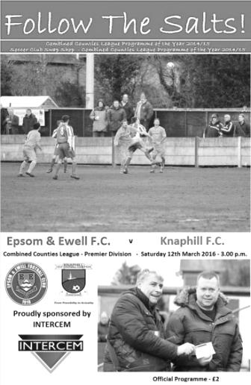
We received a significant setback in our league challenge when Knaphill came to High Road and won 2-1. However, this game, although not high in excitement or quality, did provide a few talking points that people will remember long after the match itself has been consigned to the history books.

We made a few changes after our win at Chertsey. Rhys North was struggling with a calf injury, while Rob Hendry and Michael Eacott were working and Matt Ferdinando was suspended. In their place came Adrian Jones, George Murphy, Tom Neale and Savvas 'Agi' Panayiotou and we also tried a different formation with Reisse Griffin and Matt Tanton as wing backs in a 3-5-2. Whether or not it worked is hard to say as the experiment could only be assessed for 38 minutes.

But let’s go back to the start of the match. We made a good start and scored with a superb goal after twelve minutes. A free kick was taken by Bentley Graham in a central position in the visitors half. My first thought was that it had been over hit but Murphy reached it at full stretch and volleyed the ball back across goal where James Taylor climbed highest to thump his header into the net from close range. I doubt many teams could have stopped this move and despite the visitors missing a good chance eight minutes later when shooting wide from close range after a free kick was only half cleared by our defence, we were ahead.

We nearly scored from another set piece as Panayiotou whipped in a free kick through the Knaphill wall after 24 minutes but the visitors keeper Richard Shelley was across just in time to keep the ball out at the near post and concede a corner in the process. Whether the free kick should have been a penalty was an appeal we didn't really make, as Neale had been tripped right on the line. Their keeper shortly afterwards conceded to me that he also felt it was inside the area.

Still, we were coping fairly well with the visitors to that point, although the formation always allows opposing wingers a bit of space if they can get behind our wing backs and there were sporadic dangers, especially down their left wing. Still the game meandered peacefully towards half time with little to report except a booking for the visitors Steve Brown who was beaten to a bouncing ball by Neale and caught him clumsily.

The game took a turn for the worse in the 38th minute. A harmless enough through ball looped up and Adrian Jones took the catch. From where I was, you could see the Knaphill striker bearing down on him and Jones put up his leg by way of protection. However, his studs caught the incoming player and not only was a penalty awarded but Jones was sent off. As I was at the other end of the ground I didn't get a great view but the general

consensus from people I asked was that the foot had been lifted too; a view that the referee clearly agreed with and the protesting Jones had to go. I am assuming that he was actually sent off for violent conduct, because some visiting supporters were saying that he had to go because he was the last man. Clearly this would be wrong as there is no "last man" rule; only a rule for preventing a goal scoring opportunity and this clearly wasn't the case as Jones had the ball in his hands at the time.

Either way we needed to find a keeper and Dan Dean, who had only just recovered from injury, came on between the posts to face the penalty with the unfortunate Reisse Griffin withdrawn and our experimental formation curtailed. However, it was one of the worst penalties I have ever seen at any level as Robbie Kersley put the penalty about two yards wide of Dean's right hand post!

As half time arrived, I recalled a similar situation earlier this season against Farnham when we had led early but hung on for over an hour to win with ten men and wondered if we could do the same. Instead it would turn out to be a repeat of last season's home match against Knaphill where we would lead at half time only to concede twice in the second half.

But for a while it looked like it would be our day, especially in the 58th minute when we conceded a second penalty for a trip just inside the area. Perhaps understandably, a different taker strode forward; this time Jimmy Norman, but although the strike was on target this time, it was weak and Dean went the right way and saved the ball quite comfortably! I don't have any stats for penalties saved yet, but one day when I put them together, Deano will be on the list. Additionally, I am not sure whether any other player in club history has ever been successful against two penalties in a match, certainly not a defender!

With half an hour remaining there was still much work to do and we were starting to get penned back a little. We persisted with two up front for maybe longer than we should have but they were not creating too much danger. In fact it was actually a bit of a surprise when they equalised after 71 minutes as a harmless looking cross from Timmy Taylor out on the left wing floated over everyone, including Dean, and dropped into the net. Immediately we had a chance to restore the lead as Kyle Hough got a step ahead of his man but Shelley was out quickly and was well positioned to block our striker's low shot. Our last real opportunity had gone and to add insult to injury the visitors scored a winner after 78 minutes. Like our first goal this was a very good move, with a crossfield ball to set their left winger off and he produced a superb cross that was right on the head of Norman who was able to redeem himself for the penalty miss with a simple downward header from close range.

Although Knaphill had been in good form recently this was still a disappointment as we led and appeared to have a measure of control up until the sending off, which was our eighth of the season. This would have been our worst year on record for red cards if we hadn't had eleven last year, and at the end of the season we will have to look back and see whether the points dropped as a result of these indiscretions will have cost us a promotion place.

Team: Adrian Jones, Reisse Griffin, Matt Tanton, James Taylor, George Murphy,
Craig Hastings, Bentley Graham, Matt Farrell (c), Kyle Hough, Tom Neale,
Savvas 'Agi' Panayiotou

Subs: Dan Dean for Griffin (40), Elliott Thompson for Graham (67), Sam Currie for Hastings (81)

Club Records - 15th March
Date | Day | Competition |  | Opponents |  | Scorers
15/03/30 | Sat | London League | H | Cray Wanderers | 6-1 | W.Challis (3), F.Watts (2), W.Dayman
15/03/47 | Sat | London League | H | Leavesden | 1-4 | F.Taylor
15/03/52 | Sat | Corinthian League | H | Maidstone United | 2-2 | B.Goddard (2)
15/03/58 | Sat | Corinthian League | H | Erith & Belvedere | 3-0 | D.Hermitage, o.g., T.Kerner
15/03/69 | Sat | Athenian League 2 | A | Marlow | 0-4
15/03/77 | Tue | Athenian League 1 | A | Erith & Belvedere | 1-1 | P.Weller
15/03/78 | Wed | Isthmian League 2 | H | Eastbourne United | 5-1 | T.Tuite (3), G.Archer (2)
15/03/80 | Sat | Isthmian League 1 | A | Clapton | 2-0 | A.Hill, C.Stewart
15/03/86 | Sat | Isthmian League  Premier Division | A | Yeovil Town | 0-3
15/03/88 | Tue | Isthmian League 2s | H | Chalfont St Peter | 1-4 | J.Richardson
15/03/97 | Sat | Isthmian League 3 | A | Northwood | 1-2 | N.Cawthorne
15/03/03 | Sat | Isthmian League 1s | H | Whyteleafe | 1-3 | J.Hall
15/03/05 | Tue | Associate Members  Trophy Group Stage | H | Chertsey Town | 1-1 | R.Shoefield
15/03/08 | Sat | Combined Counties  Premier Division | H | Cove | 2-1 | K.Hough, R.Burns
15/03/11 | Tue | Combined Counties  Premier Division | H | Chertsey Town | 1-4 | R.Bedj Bedj
15/03/14 | Sat | Combined Counties  Premier Division | A | Horley Town | 3-1 | M.Jarman, C.Murray-Price, J.Cottee
Historical Decades
Date | Day | Competition |  | Opponents |  | Scorers
90 years ago – Epsom Town F.C.
13/03/26 | Sat | Surrey Senior League | A | Guildford | 1-1 | R.Marlow
80 years ago – Epsom F.C.
14/03/36 | Sat | Surrey Charity Shield SF | H | Redhill | 0-2
70 years ago – Epsom F.C.
16/03/46 | Sat | London League | H | Guildford City Reserves | 4-2 | F.Chitty (2), G.Brogdale, R.Marlow
60 years ago – Epsom F.C.
17/03/56 | Sat | Corinthian League | A | Erith & Belvedere | 2-0 | B.Jenkins, J.Berry
50 years ago – Epsom & Ewell F.C.
19/03/66 | Sat | Athenian League 2 | H | Aylesbury United | 3-0 | P.Scott (2), T.Thomas
40 years ago – Epsom & Ewell F.C.
13/03/76 | Sat | Athenian League 2 | H | Edgware | 2-2 | K.Eshelby, T.Tuite
30 years ago – Epsom & Ewell F.C.
15/03/86 | Sat | Isthmian League  Premier Division | A | Yeovil Town | 0-3
20 years ago – Epsom & Ewell F.C.
16/03/96 | Sat | Isthmian League 3 | A | Wealdstone | 1-1 | S.Miller
10 years ago – Epsom & Ewell F.C.
14/03/06 | Tue | Isthmian League 2 | A | Witham Town | 1-3 | C.Pritchard

History Corner - 15th March
86 years ago today arguably the finest left winger we ever had, Wilfred “Bronk” Challis scored his only hat trick for the club in a 6-1 London League mauling of Cray Wanderers.

Alongside Jack Parr, a willing inside left, the two of them terrorised defences throughout our glory years from 1924 when Challis joined founding member Parr, up until the early thirties. Fred Watts also scored twice against a team that held out for 35 minutes but the papers said that the score flattered us a bit!

38 years ago today our record scorer Tommy Tuite scored a hat trick while Gerry Archer got the other two in a 5-1 win over Eastbourne United. We were well on our way to the title this season and this win completed a comfortable league double. Bearing this in mind it is still hard to fathom how the same team could defeat us 3-0 at West Street in the Fourth Round of the F.A. Vase in January of that season and we would have to wait 11 years before having another go at the F.A. Vase. Still the Division Two title was a nice way to end the season and this remains the last time we ever won a league.

36 years ago today we won an Isthmian League match 2-0 at Clapton. Carl Stewart scored the second goal, but the first was one of only three scored by our future Manager Adrian Hill!

30 years ago today I can still recall the excitement as we boarded the coach for our trip to Yeovil Town and their famous Huish ground for an Isthmian League Premier Division match, having drawn the home fixture 2-2 back in November. Myself and fellow long serving supporter John Steinmetz played cards for the entire duration of the journey, only for me to win the pot that had been building, just as we arrived at the ground. He wasn’t happy!

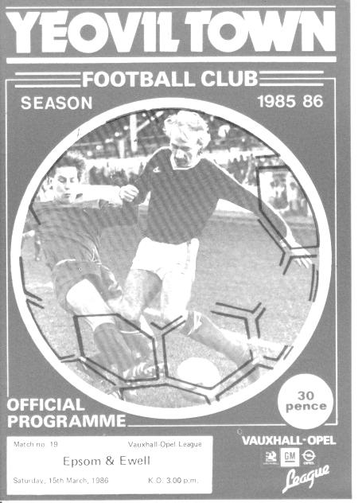
Although the result did not go well, losing 3-0, there were over 2,000 present on that memorable day as Yeovil were chasing the title, only to lose out to Sutton United and the Glovers would have to spend another season at this level. Of course we never got the chance to visit the following season as we went down that summer and in 1990 Huish was turned into a supermarket. (see programme right).

20 years ago this week our free scoring team took a trip to the White Lion Ground, Edgware, for a League match with Wealdstone. Stuart Miller scored our goal in a 1-1 draw and the following season would end up playing for them, although he would return to us afterwards.

19 years ago today we had another rare scorer as Nick Cawthorne scored his first of two goals for the club as we led but then lost 2-1 defeat at Northwood. Nick was also a regular playing member of the Epsom & Ewell Supporters FC that had started in late 1986 and would survive just into the Millennium, reaching a high point of the Leatherhead & District League Division One, just one step below the top flight. We have had a few players who have played for both teams but Nick played most games for our club, reaching 54 in total over a two year span, and was also in attendance at Redhill earlier this season for our league win as he lives nearby!

8 years ago today we met Cove in a League game at Merland Rise, winning 2-1 with or fearsome strike pairing of Kyle Hough and Robbie Burns both finding the net this day.

First Eleven Appearances - (max 36 – including Knaphill – 12/03/16)
Name | Debut | 2015/16 |  |  |  | Career Totals
 |  | App | Sub | Total | Goals | App | Sub | Total | Goals
AJAYI Tayo* | 22/08/2015 | 0 | 2 | 2 | 0 | 0 | 2 | 2 | 0
COOPER-SMITH Daryl | 03/01/2015 | 15 | 4 | 19 | 8 | 24 | 7 | 31 | 14
CURRIE Sam | 04/08/2012 | 16 | 5 | 21 | 1 | 124 | 14 | 138 | 3
DAVISON Conor* | 22/08/2015 | 1 | 2 | 3 | 0 | 1 | 2 | 3 | 0
DEAN Dan | 02/08/2014 | 22 | 3 | 25 | 0 | 58 | 4 | 62 | 0
DOWNS Carl | 17/09/2011 | 5 | 1 | 6 | 0 | 99 | 14 | 113 | 2
EACOTT Michael | 02/08/2014 | 31 | 0 | 31 | 0 | 77 | 0 | 77 | 0
FARRELL Matt | 02/08/2014 | 35 | 0 | 35 | 6 | 76 | 3 | 79 | 13
FERDINANDO Matt | 20/09/2014 | 24 | 1 | 25 | 8 | 51 | 5 | 56 | 14
GRAHAM Bentley | 09/02/2016 | 7 | 0 | 7 | 1 | 7 | 0 | 7 | 1
GRIFFIN Reisse | 08/08/2015 | 17 | 6 | 23 | 1 | 17 | 6 | 23 | 1
HASTINGS Craig | 08/08/2015 | 29 | 3 | 32 | 0 | 29 | 3 | 32 | 0
HATFIELD Jamie | 11/11/2006 | 1 | 0 | 1 | 0 | 249 | 13 | 262 | 6
HENDRY Rob | 08/08/2015 | 27 | 6 | 33 | 12 | 27 | 6 | 33 | 12
HOUGH Kyle | 14/08/2007 | 26 | 4 | 30 | 21 | 322 | 19 | 341 | 192
JONES Adrian | 06/08/2011 | 4 | 1 | 5 | 0 | 24 | 1 | 25 | 0
KURDZIEL Jakub* | 29/08/2015 | 1 | 0 | 1 | 0 | 1 | 0 | 1 | 0
MARVELL Dale* | 15/01/2000 | 8 | 4 | 12 | 1 | 269 | 49 | 318 | 86
McGREGOR Alex* | 08/08/2009 | 7 | 3 | 10 | 2 | 179 | 59 | 238 | 29
MCKAY Alex | 20/12/2008 | 23 | 1 | 24 | 0 | 108 | 27 | 135 | 8
MURPHY George | 19/03/2013 | 1 | 0 | 1 | 0 | 67 | 6 | 73 | 3
NEALE Thomas | 13/10/2015 | 13 | 11 | 24 | 6 | 13 | 11 | 24 | 6
NEILL David* | 03/10/2015 | 1 | 1 | 2 | 0 | 1 | 1 | 2 | 0
NORTH Rhys | 16/08/2015 | 16 | 7 | 23 | 1 | 16 | 7 | 23 | 1
OLIVER Beckett | 29/08/2015 | 5 | 11 | 16 | 0 | 5 | 11 | 16 | 0
PANAYIOTOU Savvas | 03/01/2015 | 8 | 3 | 11 | 1 | 24 | 6 | 30 | 4
ROBINSON Sam* | 22/10/2011 | 0 | 1 | 1 | 0 | 54 | 5 | 59 | 13
ROWE Steve | 27/08/2011 | 0 | 1 | 1 | 0 | 24 | 3 | 27 | 0
SMITH Matt | 08/08/2009 | 0 | 0 | 0 | 0 | 91 | 43 | 134 | 10
TANTON Matt | 02/08/2014 | 30 | 0 | 30 | 0 | 48 | 4 | 52 | 1
TAYLOR James | 26/08/2013 | 21 | 3 | 24 | 3 | 77 | 11 | 88 | 6
THOMPSON Elliott | 09/02/2016 | 2 | 5 | 7 | 0 | 2 | 5 | 7 | 0
Own Goal |  |  |  |  |  |  |  |  | 1
* Player has left the club

Combined Counties League Premier Division Opponents
All-time Records
inc Saturday 12th March | P | W | D | L | F | A | PPG | GD | Best  Win | Worst  Loss
Spelthorne Sports* | 5 | 4 | 1 | 0 | 15 | 6 | 2.60 | +9 | 6-2 | -
Sutton Common Rovers | 10 | 8 | 1 | 1 | 27 | 12 | 2.50 | +15 | 4-0 | 1-4
Horley Town | 28 | 19 | 5 | 4 | 62 | 30 | 2.21 | +32 | 6-0 | 1-3
Westfield | 17 | 11 | 3 | 3 | 39 | 27 | 2.12 | +12 | 6-1 | 0-4
Colliers Wood United | 21 | 14 | 2 | 5 | 45 | 28 | 2.10 | +14 | 4-0 | 0-3
Bedfont Sports | 9 | 5 | 2 | 2 | 13 | 10 | 1.89 | +3 | 3-0 | 0-4
Guildford City | 15 | 8 | 1 | 6 | 27 | 21 | 1.67 | +6 | 4-0 | 1-5
Knaphill | 6 | 3 | 1 | 2 | 11 | 8 | 1.67 | +3 | 4-1 | 1-2
Farnham Town | 12 | 6 | 2 | 4 | 21 | 21 | 1.67 | 0 | 3-1 | 1-4
Raynes Park Vale | 25 | 12 | 5 | 8 | 54 | 36 | 1.64 | +18 | 6-1 | 0-2
Hanworth Villa | 13 | 6 | 3 | 4 | 31 | 22 | 1.62 | +9 | 5-0 | 1-4
Camberley Town* | 87 | 38 | 21 | 27 | 156 | 120 | 1.57 | +36 | 9-1 | 0-4
Chessington & Hook | 27 | 11 | 9 | 7 | 52 | 41 | 1.56 | +11 | 6-0 | 1-3
Cove | 33 | 14 | 9 | 10 | 74 | 55 | 1.55 | +19 | 7-0 | 1-6
Hartley Wintney | 10 | 4 | 3 | 3 | 25 | 17 | 1.50 | +8 | 5-0 | 2-4
Windsor | 47 | 18 | 12 | 17 | 87 | 88 | 1.40 | -1 | 4-0 | 0-6
Redhill | 33 | 14 | 2 | 17 | 63 | 69 | 1.33 | -6 | 7-2 | 2-8
Badshot Lea | 16 | 6 | 3 | 7 | 27 | 32 | 1.31 | -5 | 3-0 | 0-4
Chertsey Town | 47 | 17 | 5 | 25 | 70 | 86 | 1.19 | -16 | 3-0 | 0-7
Ashford Town (Mx) | 17 | 4 | 2 | 11 | 22 | 44 | 0.82 | -22 | 3-0 | 0-5
AFC Hayes | 7 | 1 | 2 | 4 | 9 | 15 | 0.71 | -6 | 3-1 | 0-3
Total* | 485 | 223 | 94 | 167 | 930 | 788 | 1.58 | 142 | - | -
* includes one abandoned match v Camberley and one loss on penalties v Spelthorne

Cove F.C. – History
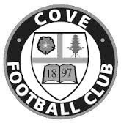
Cove F.C. were formed in 1897 by a group of local people playing on a field behind their favourite Public House.

Moving to a more central location, Cove Green became their home until 1973, when they moved to their present ground at Oak Farm. Playing their football in The Surrey Leagues, Cove enjoyed success for many years, winning more than their fair share of silverware in this time, including the League Championship three years in succession and a double.

In 1973, the club decided to upgrade and were accepted into the Hampshire Leagues, but had to leave 'The Green' for safety reasons. The Division 4 Championship was won at the first attempt, and the Division 3 title followed 2 years later. After a couple of seasons, Cove finished Runners-Up in Division 2, but decided to withdraw from this league due to the time taken to away matches in Portsmouth or Southampton, before the M3 motorway was built.

Thus they returned to the more local Combined Counties League in 1980, and won the League Cup beating close neighbours and rivals Ash United. Since moving into their new home, many changes have taken place at Oak Farm with the installation of floodlights a concrete perimeter wall and stand in their quest to house senior non-league football. These achievements are the more remarkable with Farnborough Town (then Conference League) and Aldershot Town (then Football League) just a couple of miles down the road.

In 1990, Cove were given the chance to join the Vauxhall League (now Ryman League) after finishing third. New manager ‘Chick’ Botley assembled a squad strong enough to finish a respectable fourth in their first season. Two more successful seasons followed narrowly missing out on promotion, once a final day defeat by the new Aldershot Town. Due to the ever spiralling cost of football at this level, Cove were forced to withdraw and had to revert back into The Combined Counties League, where they remained with little success.

After finishing bottom of the league two years running, Cove Football Club appointed Steve Beeks, a young man with no managerial experience, but a good playing record which included a period as professional at Aldershot until their demise in 1990. Within 12 months Cove were on their way back, having regained some respect among the local clubs, and were no longer the ‘Whipping Boys’ finishing a creditable 8th., allowing entry back into the top competitions.

Season 2000-2001 saw Cove reach the 5th round of the F.A. Vase beating some more senior clubs along the way, before losing out to Chippenham Town, and a F.A.Cup victory at Ryman Division One side Bognor Regis. The Premier Challenge Cup was won 3-0 over Walton Casuals and was soon followed by the victory over closest rivals, AFC Wallingford, that ensured the League Championship, breaking all league records on the way, which included reaching the magic 200 goals scored in all competitions to complete a memorable season.

With the departure of Steve Beeks, the club suffered many traumatic years as different managers tried to lift the club back to the dizzy heights of the late 1990’s but with little success. In 2009 the club appointed Koo Dumbuya as manager and a member of the Steve Beeks double winning team and well known around the area. Having played professional football for Aldershot and Brentford, the club decided his playing experience and knowledge could be invaluable and in his first season won the Southern Combination Cup 4-0 over Chessington and Hook United.

In 2010 Cove won the Combined Counties League Cup with a 2-0 win over Bedfont, followed by a victory over Farnborough Town in the semi-final of the Aldershot Senior Cup before losing to Fleet Town in the final.

In 2011 manager Koo Dumbuya left the club after 4 years as player and manager to take up a post at Chertsey Town, leaving a big hole to fill as his knowledge of local football is immense. The task of filling this hole was left to his assistants Paul Duncan and Simon Brand to rebuild the team from new as 9 players left at the end of the previous season. On a happier note, President and old player, Frank Kenton, and Secretary Graham Brown both received an award from Hampshire FA for 25 years service.

During season 2012/13 following some poor performances, the club employed Dan Reeves and old player Anthony Millerick which brought instant success with the winning of the Aldershot Senior Cup and a 3-0 victory over Fleet Spurs, also finishing 3rd in the League, our highest position for many a year. 2013-2014 was another successful season finishing 5th after a run of 22 games, 19 wins and 1 defeat.

2014/15 was a very successful year sitting on top of the league for half the season, but unable to go for promotion due to the cost of ground improvements and travel, saw a considerable dip in form leading to a fifth place finish and a mass exodus of management and players.

A complete change of personnel followed with the appointment of Dave Matthews as manager, following his success as Youth Team coach, accepting the challenge of building a new team capable of retaining their position in the Premier Division. However, things haven’t gone well and Dave stepped back from the role with Paul Duncan taking over the reins in December 2015.

No resume of Cove F.C. would be complete without mentioning Ron Brown, who in 1990 received an F.A. award for 50 years service to Cove F.C., including 35 years as secretary. Ron retired in 1982 passing the reins to his son Graham who has himself completed 28 years in the job. Sadly Ron passed away in 2009 after 70 years service including 20 years as Club President. On a happier note, President and old player, Frank Kenton, and Secretary Graham Brown were both to receive an award from Hampshire FA for 25 years’ service.

Player Profile – Number 17 – Elliott Thompson
Our latest profile is from one of our newest players, Elliott Thompson.

Age: 25

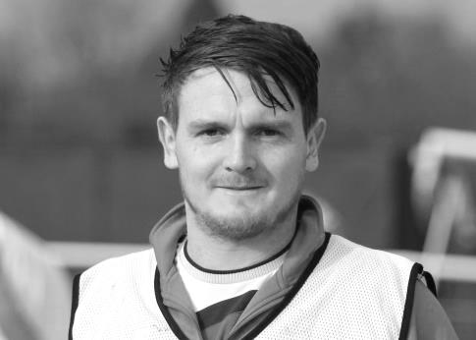
Position: Centre midfield but played various positions throughout career

Club supported: Chelsea

Favourite Food: KFC

Favourite Film: Training Day

Messi or Ronaldo: Ronaldo

Favourite Drink: Vodka, lemonade and lime

Favourite Ground played at: Stamford Bridge

Best moment for Epsom: Ask me again in a few weeks!

Describe the Gaffa in three words: Blows - His - Top

Elliott’s Playing Stats: First Team Debut : 09/02/2016

Appearances: 2 - Sub: 5 - Total: 7 - Goals: 0

Centre page for results

Centre page for results

Every Opponent A-Z
Over the years we have played many, many different opponents. Exactly how many is a difficult question, as it all depends on your definition. Are Camberley & Yorktown different to Camberley Town, or are Epsom Town different to Epsom F.C. or Epsom & Ewell F.C.?

In my analysis I have classed them as the same team, and will work through them all from A to Z. Some we have played many times, whilst others we have met just once or twice. Enjoy!

Ruislip Manor: Played 30 - W11 D4 L15 - F44 A60 - PPG - 1.23 - Below Average

The original inhabitants of Grosvenor Vale were founded in 1938 and used to meet us quite regularly throughout the sixties, seventies and eighties, but our very first match was an Amateur Cup tie at West Street on Saturday 12th November 1955. We trailed at the half but three goals in the second half from Jan Sorensen, Johnny Berry and Gordon Cairns saw us through to a final qualifying round tie at Redhill with a 3-1 win. Somewhat bizarrely, we then drew them again the very next season, in the same competition and even the same round, albeit this time at the Vale where a hat trick from future professional winger Ray Colfar saw us through much more comfortably this time as we won 6-1 there.

Our next batch of meetings came following our relegation to the Athenian League Division Two in 1965 and for the next eight seasons we would compete. Neither side were great during that time and for the first seven of those seasons, neither team even finished in the top half, with Ruislip bottom in 1965/66 and 1969/70 while we took that position for the two seasons after that.

In 1965/66 and despite their finishing position they still won 1-0 at West Street in the September although we did at least win the return 2-0 at Grosvenor Vale. In 1966/67 we were blown away 5-1 over there but in the return match, ironically on the very day I was born, Saturday 21st January 1967 we produced a 6-5 victory at West Street with two goals each from Tony Farmiloe and from our Player / Manager Tony Williams.

In 1967/68 both sides won the away match by a goal to nil but the 1968/69 season was awful, losing both matches 3-0. Bearing this in mind it was probably a surprise when we opened up the 1969/70 season with a 2-1 home win over Ruislip Manor and it was our turn to complete a double with a 2-0 away win. That final match was crucial, as a draw would have meant that we would have finished bottom instead and bearing in mind the poor seasons that followed and the re-election battles that followed, we may not have made it to our watershed year of 1973 at all as we may have been dropped sooner!

During the next three seasons we were to lose all six of our meetings although the final one of those in March 1973 ended up as a 4-3 defeat, despite having led 3-2 at the half. This was a great performance as this was the year that they broke out, winning the title and being promoted. Suddenly we were two divisions apart as the Athenian League cast us loose in the summer of 1973.

As regular readers know, we returned to the Athenian League in 1975 after our Surrey Senior League title and FA Vase Final appearance and went straight up in to be paired once again for 1976/77 but this time in Division One, which had by now become the top flight of the Athenian League, following the Isthmian League’s first expansion in 1973/74. We won 5-2 there on a day memorable for Tommy Tuite scoring all five goals, but were held 0-0 at West Street in April 1977.

By this time we were lined up for a move into the Isthmian League as it expanded for a second time in 1977 and Ruislip Manor found their way into the London Spartan League. We met there once

for a London Senior Cup tie on 13th November 1982. It was my first visit there and I recall a great free kick from Dave Barnard helping us to a 3-0 lead, only to get that hollow empty feeling as the home side fought back to make it 3-3 with minutes remaining. With extra time looming Steve Hill popped up to score a late winner and we scraped through 4-3.

The Isthmian League expanded for a third time in 1984 and this time The Manor were able to join. In October of 1985 we visited for an Isthmian League Cup tie where this time extra time was required with Peter Kemp scoring the winner after Robin Lewis had scored in normal time. However, we had been expected to win as we were two divisions above them, which told you we were in trouble and two relegations in two seasons ensured that we were placed in Division Two South and league meetings recommenced from that point.

Our first meeting of that sequence was the most memorable as we were chasing a quick return to the First Division and were well placed until Saturday 19th December 1987 when they came to West Street and won 6-1. The math was so decisive their defender Charlie Turlough even had time while defending a corner to tell us the topical at the time joke about Lester Piggott! Our keeper that day Terry Victory never played for the club again although all players were bad that day so it was a bit of a surprise when we managed to secure a 1-1 draw over there in the return in April.

Still the fun was short lived. We drew there 1-1 again in 1988/89 but also lost the home match 1-0 and in 1989/90 a 5-0 defeat at home to the rampant Manor was probably the time our Directors felt that it was time for a change of Management, as Ricky Kidd was replaced by the returning Adrian Hill a few months later, even though we secured another draw, 0-0, in one of Ricky’s final matches in charge in February 1990.

The 1990/91 season was the last in which we would meet, winning 1-0 at home with a Dave Fry penalty to break that horrible sequence, but we then lost 2-0 in the return in April 1991 and when the Divisions were split from North and South into Divisions Two and Three, we just missed out.
The old ground at Grosvenor Vale. Note the old WW2 turret in the right corner
And we never met again. They remained an Isthmian club, moving up to Division One in 1992/93 where they remained until resigning in 1996 and in 2008 they lost their ground to Wealdstone, who just jumped in and evicted them, magpie style.

The club Committee resigned but they rebuilt under a new name, Tokyngton Manor, originally at the old Viking Sports Ground in Greenford before it was deemed unsafe. They currently share at Amersham Town but regrettably are now playing at Step Seven in the Middlesex County League.
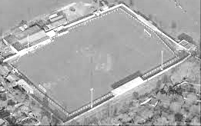

CCL Premier Division Club Directory
A.F.C. HAYES Telephone: 0208-845-0110 - Ground: Farm Park, Kingshill Avenue, Hayes, Middx. UB4 8DD - Colours: Blue and White Stripes/Blue/Blue

ASHFORD TOWN (Mx) Telephone: 01784-245908 - Ground: The Robert Parker Stadium, Short Lane, Stanwell, Middx. TW19 7BH - Colours: Tangerine & White Stripes/Black/Tangerine

BADSHOT LEA Telephone: 01252-320385 - Ground: Ash United FC, Shawfield Stadium, Youngs Drive, Shawfields Road, Ash, Hampshire. GU12 6RE - Colours: Claret/White/Claret

BEDFONT SPORTS Telephone: 0208-831-9067 - Ground: Bedfont Sports Club, Hatton Road, Bedfont, Middx TW14 8JA - Colours: Red & Black Hoops/Black/Red & Black Hoops

CAMBERLEY TOWN Telephone: 01276-65392 - Ground: Krooner Park, Wilton Road, Camberley, Surrey. GU15 2QW - Colours: Red & White Stripes/Blue/Red

CHERTSEY TOWN Telephone: 01932-561774 - Ground: Alwyns Lane, Chertsey, Surrey. KT16 9DW - Colours: Royal Blue & White Stripes/Royal Blue/Royal Blue

CHESSINGTON & HOOK UNITED Telephone: 01372-602263 - Ground: Chalky Lane, Chessington, Surrey. KT9 2NF - Colours: Blue/Blue/Blue

COLLIERS WOOD UNITED Telephone: 0208-942 8062 - Ground: Wibbandune Sports Ground, Robin Hood Way, Wimbledon. SW20 0AA - Colours: Blue & Black Stripes/Black/Black

COVE Telephone: 01252-543615 - Ground: Oak Farm Fields, 7 Squirrel Lane, Cove, Farnborough, Hampshire. GU14 8PB - Colours: Yellow/Black/Yellow

EPSOM & EWELL Telephone: 01737-553250 - Ground: Chipstead FC, High Road, Chipstead, Surrey. CR5 3SF - Colours: Royal Blue & White Hoops/Royal Blue/Royal Blue

FARNHAM TOWN Telephone: 01252-715305 Ground: Memorial Ground, Babbs Mead, West Street, Farnham, Surrey. GU9 7DY Colours: - Claret & Sky Blue /White/ Claret & Sky Blue

GUILDFORD CITY Telephone: 01483-443322 - Ground: The Spectrum, Parkway, Guildford, Surrey. GU1 1UP - Colours: Red & White Stripes/Black/Black

HANWORTH VILLA Telephone: 0208-831-9391 - Ground: Rectory Meadows, Park Road, off Hounslow Road, Hanworth, Middlesex. TW13 6PN - Colours: Red & White Stripes/Black/Black

HARTLEY WINTNEY Telephone: 01252-843586 - Ground: Memorial Playing Fields, Green Lane, Hartley Wintney, Hants RG27 8DL - Colours: Orange & Black/ Orange /Orange

HORLEY TOWN Telephone: 01293-822000 - Ground: The New Defence, Anderson Way, Court Lodge Road, Horley, Surrey. RH6 8SP - Colours: Claret & Sky Blue/Claret/Claret

KNAPHILL Telephone: 01483-475150 - Ground: Brookwood Country Park, Redding Way, Lower Guildford Road, Knaphill, Surrey. GU21 2AY - Colours: Red/Black/Red

SUTTON COMMON ROVERS Telephone: 01932-866386 - Ground: Sutton United FC, Gander Green Lane, Sutton, Surrey SM1 2EY - Colours: Yellow/Black/Black

RAYNES PARK VALE Telephone: 020-8540-8843 - Ground: Prince Georges Playing Field, Grand Drive, Raynes Park, London. SW20 9NB - Colours: Blue/Blue/Red

REDHILL Telephone: 01737-762129 - Ground: Kiln Brow, Three Arch Road, Redhill, Surrey RH1 5AG - Colours: Red and White Stripes/Black/Red

SPELTHORNE SPORTS Telephone: 01932-961055 - Ground: Spelthorne Sports Club, 296 Staines Road, Ashford Common, Ashford, Middx. TW15 1RY - Colours: Light & Dark Blue/Dark Blue/Light Blue

WESTFIELD Telephone: 01483-771106 - Ground: Woking Park, Kingfield Road, Woking, Surrey. GU22 9BA - Colours: Yellow/Black/Black

WINDSOR Telephone: 01753-860656 - Ground: Stag Meadow, St Leonards Road, Windsor, Berks SL4 3DR - Colours: Red/Red/Red

F.A. Vase
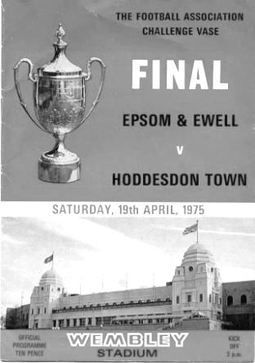
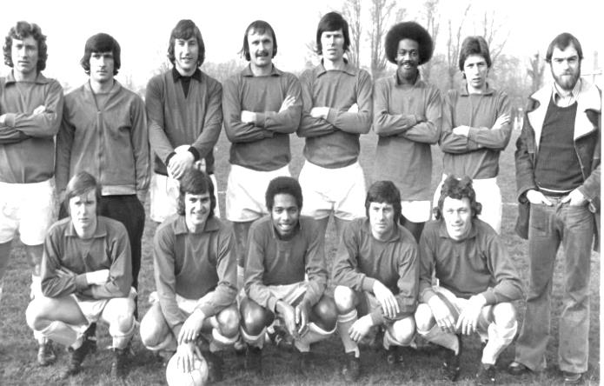
Fourth Round
Cleethorpes Town | 2-1 | Alvechurch
Hereford | 6-0 | Leicester Nirvana
Morpeth Town | 2-0 | North Shields
Coleshill Town | 1-3+ | Dunston UTS
AFC Wulfrunians | 2-3 | Nuneaton Griff
Sunderland RCA | 3-2 | Sleaford Town
Newton Aycliffe | 2-0 | Marske United
Bowers & Pitsea | 3-0 | Sutton Common Rovers
Kidlington | 3-2 | Knaphill
Newport IOW | 1-2+ | Ashford United
Moneyfields | 0-2 | Bristol Manor Farm
FC Romania | 1-2 | Camberley Town
AFC Dunstable | 0-3 | Salisbury
Berkhamsted | 4-2 | Hullbridge Sports
Hartley Wintney | 3-1 | Bradford Town
Bodmin Town | 1-3 | Ipswich Wanderers
Fifth Round
Ipswich Wanderers | 1-1+r1-2 | Bowers & Pitsea
Sunderland RCA | 2-3 | Bristol Manor Farm
Camberley Town | 5-0 | Newton Aycliffe
Berkhamsted | 1-2 | Morpeth Town
Cleethorpes Town | 1-2 | Kidlington
Nuneaton Griff | 0-3 | Salisbury
Ashford United | 1-1+r3-2 | Dunston UTS
Hartley Wintney | 1-4 | Hereford
Quarter Final
Hereford | 3-2+ | Camberley Town
Salisbury | 3-0 | Ashford United
Morpeth Town | 2-0 | Bristol Manor Farm
Bowers & Pitsea | 3-3+4-0 | Kidlington
Semi Final (two legs) 12-03-16 and 19-03-16
Hereford | 1-0 | Salisbury
Morpeth Town | 2-2 | Bowers & Pitsea

Player Sponsorship
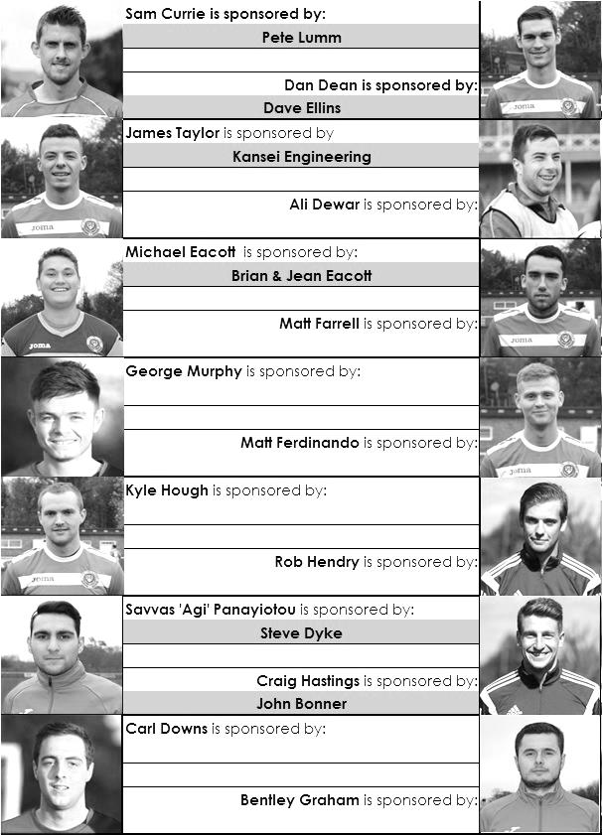

Here is the current list for the 2015/16 season showing all of our players and Management that are currently available for sponsorship this season.

Sponsorship costs just £40 and it is easy to do. Just select a player who has not been previously sponsored and let a Committee Member know that you would like to sponsor them. Beware though. Until we have received the money it is possible for someone to jump in front of you, so don’t delay, sponsor today!
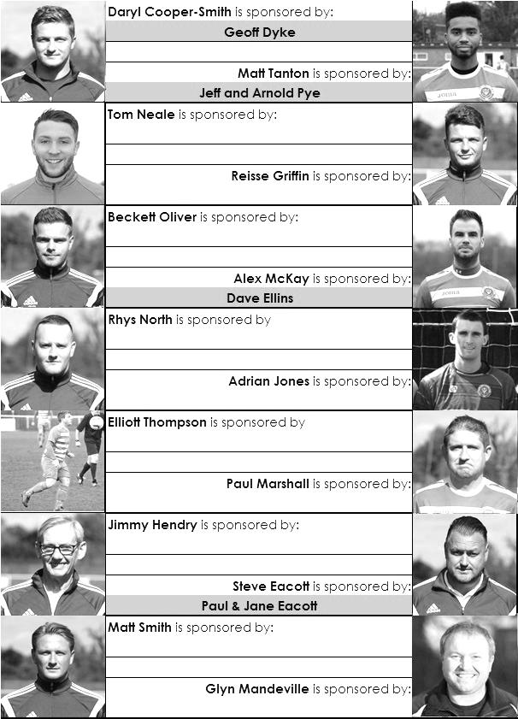

Match and Ball Sponsorships – 2015/16
Opponent | Date | Match Sponsor | Match Ball Sponsor
Hoddesdon Town | 18/07/15 | Geoff Dyke
Windsor | 08/08/15 | Club President - Stella Lamont
Erith & Belvedere (FAC) | 16/08/15 | Committee Member - Mike Lovett
Raynes Park Vale | 31/08/15 | EEFC Management Committee
Colliers Wood United | 08/09/15 | Bookham Building Shop – www.buildingshop.co.uk
AFC Hayes | 19/09/15 | John Bonner
Farnham Town | 26/09/15 | Ezara and Inaya Beddoe – our youngest supporters!
Chertsey Town | 17/10/15 | Club Media Officer – Richard Lambert
Dorking Wanderers (SSC) | 20/10/15 | Tony Ferdinando
Chessington & Hook United | 07/11/15 | Paul Merritt
Hanworth Villa | 21/11/15 | Maggie Beddoe
Guildford City | 05/12/15 | Pete Lumm
Sutton Common Rovers | 19/12/15 | Marvin Hough
Ashford Town (Mx) (LC) | 12/01/16 | Pete Beddoe & Steve Dyke
Redhill | 02/02/16 | David Lawton
Bedfont Sports | 13/02/16 | Bookham Building Shop – www.buildingshop.co.uk
Hartley Wintney | 23/02/16 | EEFC Management Committee
Horley Town | 27/02/16 | Jeff and Arnold Pye
Spelthorne Sports | 01/03/16 | In memory of Chris Henry
Knaphill | 12/03/16 | Marvin Hough
Cove | 15/03/16 | Mark & Carmel Murphy
Westfield | 26/03/16 | Nathan Lambert
Badshot Lea | 09/04/16 | Tony Coome
Camberley Town | 16/04/16 | Marvin Hough
Ashford Town (Mx) | 30/04/16 | Club President - Stella Lamont
Ashford Town (Mx) | 30/04/16 | Brian Eacott | Steve Dyke
For League, League Cup and Surrey Senior Cup Matches:
Match sponsorship - £40.00 Match ball sponsorship - £25.00. Combined £55.00.
For F.A. Cup and F.A. Vase matches:
Match sponsorship - £50.00 Match ball sponsorship - £30.00. Combined £65.00.

Sponsorship includes: ( x2 for match, x3 for match and ball )

Admission, programmes, hospitality, advertising and mascot for the day (if required ).
If you are interested, just speak to a Committee Member, or drop me an email at: richard.c.lambert@gmail.com

We also thank our Kit Sponsors INTERCEM

Salts Super Six Predictor
The Salts Super Six Predictor Competition is live again and the tickets are on sale at today’s game to the left of the gate. We recently had our third Super Six win but the jackpot is building up again already!

The competition is easy to play! To win, you simply need to predict the results of the six matches correctly from the three options, fill in the form and make sure it is back with our sellers before the deadline on the ticket.

If you are a club regular, you just need to place your name on the sheet, although if you aren’t, then we’ll need a contact number from you too. We will announce any winners on the website very quickly, so don’t worry we won’t miss you!
The jackpot is now at £93 and who knows how high it could go this time!

Please note that if there is more than one winner, the prize pot would be shared between the winners. All you need to do now is have a go, as many times as you like!

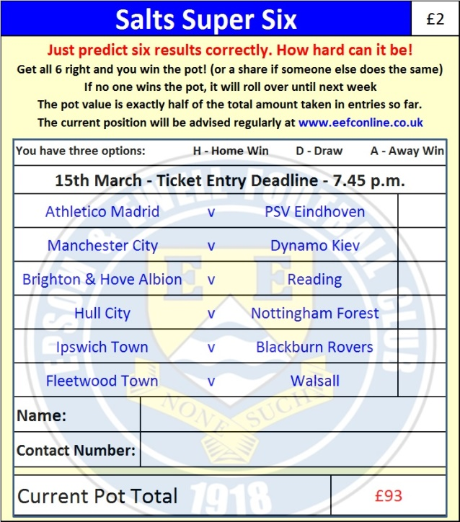

Good luck!

Combined Counties League – Premier Division
Tuesday, 15th March 2016 - Kick-off 7.45 p.m.
Epsom and Ewell  (Royal Blue & White hoops) | V |  | Cove  (Yellow and Black)
Squad | NUMBERS
Michael Eacott |  |  | Aiden Upward
Rhys North |  |  | Aaron Watkins
Matt Tanton |  |  | Matt Day
James Taylor |  |  | Jordan Chandler
Craig Hastings |  |  | Mike Flounders
Bentley Graham |  |  | Richard Jeffrey
Savvas ‘Agi’ Panayiotou |  |  | George Dore
© Matt Farrell |  |  | Sam Lynam
Kyle Hough |  |  | Bobby Mitchell
Tom Neale |  |  | Jordan Dowdican
Reisse Griffin |  |  | Liam Hulaitt
Elliott Thompson |  |  | Steven Eyanga-Bwanga
Dan Dean |  |  | Neil Rossiter
George Murphy |  |  | Luke Lewis
Rob Hendry |  |  | Otis Taylor
Alex McKay |  |  | Gurkan Gokman
Adrian Jones |  |  | Lennon Wesley
Sam Currie
Beckett Oliver
Carl Downs
Matt Ferdinando
Glyn Mandeville | MANAGER |  | Paul Duncan
Matt Smith | ASSISTANT |  | Salv Di Prima
Steve Eacott / Alex McKay / Jimmy Hendry | COACHES / PHYSIO |  | Teagan-Christine Brown
REFEREE: A.Lashchikov (London SW11)
ASSISTANTS: K.Parker (Roehampton, K.Corrick (Oxted)
Today’s Match and Match Ball are sponsored by
Mark and Carmel Murphy, parents of our defender George

OUR NEXT VISITORS TO HIGH ROAD ARE:
Westfield F.C.
***** Good Friday 25th March 2016 - Kick-off 1.00 p.m. *****
Combined Counties League – Premier Division

